Practical -1

1. Write a program to calculate area of a Circle (A = πr2) (A)

#include<stdio.h>

float findArea(float r){

    return  3.14\*r\*r;

}

void main(){

    float radius=0;

    printf("Enter The Radius of Cicle : ");

    scanf("%f",&radius);

    printf("The radius of the circle is %f",findArea(radius));

}

Output :-

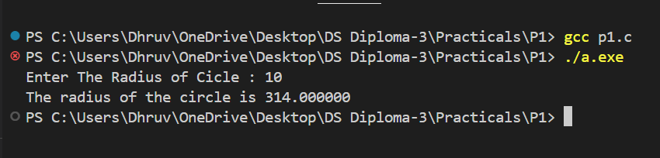

2. Write a program to ƒind whether a number is odd or even(A).

#include<stdio.h>

void oddOrEven(int n){

    if(n%2==0)

        printf("Number is even");

    else

        printf("Number is odd");

}

void main(){

    int n;

    printf("Enter Number : ");

    scanf("%d",&n);

    oddOrEven(n);

}

Output :-

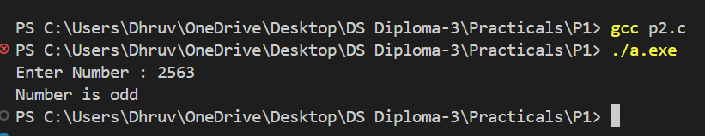

3. Write a program to ƒind factorial of a number. (Using Loop) (A).

#include<stdio.h>

int fact(int n){

    int fact=1,i;

    for(i=1;i<=n;i++){

        fact\*=i;

    }

    return fact;

}

void main(){

    int n;

    printf("Enter Number : ");

    scanf("%d",&n);

    printf("factorial of %d is %d",n,fact(n));

}

Output:-

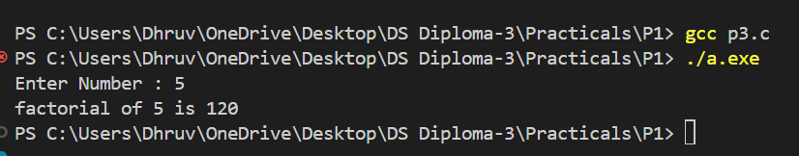

4. Write a program to ƒind power of a number using loop.(A)

#include <stdio.h>

int power(int base, int exponent) {

    int result = 1;

    for (int i = 0; i < exponent; i++) {

        result \*= base;

    }

    return result;

}

int main() {

    int base, exponent;

    // Input from user

    printf("Enter the base: ");

    scanf("%d", &base);

    printf("Enter the exponent: ");

    scanf("%d", &exponent);

    int result = power(base, exponent);

    printf("%d to the power of %d is %d\n", base, exponent, result);

    return 0;

}

Output:-

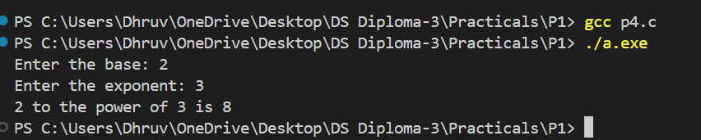

5. Write a program to ƒind factors of a given number.(B)

#include<stdio.h>

void factors(int n){

    int i;

    for(i=1;i<=n;i++){

        if(n%i==0)

            printf("%d,",i);

    }

}

void main(){

    int n;

    printf("Enter Number: ");

    scanf("%d", &n);

    factors(n);

}

Output:-

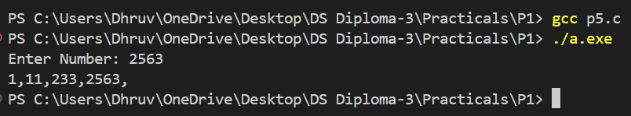

6. Write a program to check whether a number is prime or not.(B)

#include<stdio.h>

void isPrime(int n){

    int i;

    int flag=0;

    for(i=2;i<n;i++){

        if(n%i==0){

            flag=1;

            break;

        }

    }

    if(flag==0)

        printf("number is prime  ");

    else

        printf("number is not prime");

}

void main(){

    int n;

    printf("enter number");

    scanf("%d",&n);

    isPrime(n);

}

Output:-

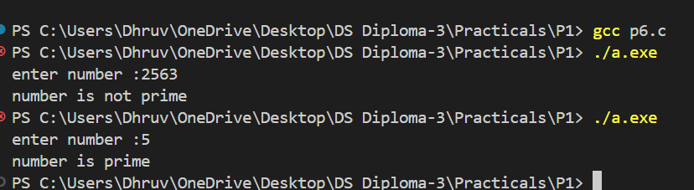

7. Write a program to ƒind the sum of 1 + (1+2) + (1+2+3) + …+(1+2+3+4+….+n).(C)

#include<stdio.h>

int sum(int n){

    int i,j,sum=0;

    for(i=1;i<=n;i++){

        for(j=1;j<=i;j++){

            sum+=j;

        }

    }

    return sum;

}

void main(){

    int n;

    printf("Enter number : ");

    scanf("%d", &n);

    printf("sum : %d",sum(n));

}

Output:-

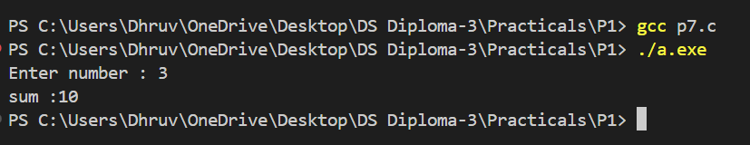

8. Write a program to print Armstrong number from 1 to 1000. (C)

#include<stdio.h>

#include<stdbool.h>

int pow(int base,int exponent){

    int result=1,i;

    for(i=1;i<=exponent;i++){

        result\*=base;

    }

    return result;

}

bool armstrong(int n){

    int temp=n,len=0,sum=0;

    while(0<n){

        len++;

        n=(int)n/10;

    }

    n=temp;

    while(0<n){

        int digit = n%10;

        sum=sum+pow(digit,len);

        n=(int)n/10;

    }

    if(temp==sum) {

        return true;

}

    else{

        return false;

}

}

void main(){

    int i;

    for(i=1;i<1001;i++){

        if(armstrong(i))

            printf("%d ",i);

    }

}

Output:-

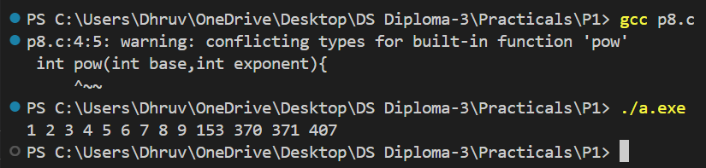

Practical -2

1. Write a program to read and display n numbers using an array. (A)

#include <stdio.h>

int main() {

    int n;

    // Input number of elements

    printf("Enter the number of elements: ");

    scanf("%d", &n);

    int arr[n];

    // Read elements into array

    printf("Enter %d numbers: ", n);

    for (int i = 0; i < n; i++) {

        scanf("%d", &arr[i]);

    }

    // Display elements of the array

    printf("The numbers are: ");

    for (int i = 0; i < n; i++) {

        printf("%d ", arr[i]);

    }

    printf("\n");

    return 0;

}

Output :-

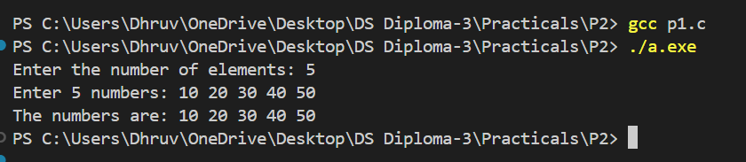

2. Write a program to calculate the sum of numbers from 1 to n. (A)

#include <stdio.h>

int main() {

    int n, sum = 0;

    // Input the value of n

    printf("Enter a number: ");

    scanf("%d", &n);

    // Calculate the sum of numbers from 1 to n

    for (int i = 1; i <= n; i++) {

        sum += i;

    }

    // Display the sum

    printf("The sum of numbers from 1 to %d is %d\n", n, sum);

    return 0;

}

Output :-

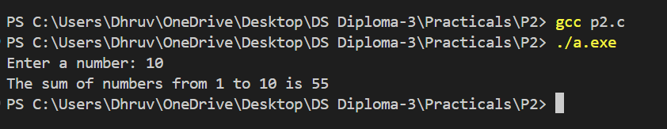

3. Write a program to insert an element into an array at a given position.(A)

#include <stdio.h>

int main() {

    int n, pos, element;

    printf("Enter the number of elements: ");

    scanf("%d", &n);

    int arr[n+1]; // Extra space for the new element

    printf("Enter %d numbers: ", n);

    for (int i = 0; i < n; i++) {

        scanf("%d", &arr[i]);

    }

    // Input position and element to insert

    printf("Enter the position to insert (0 to %d): ", n);

    scanf("%d", &pos);

    printf("Enter the element to insert: ");

    scanf("%d", &element);

    // Insert element at the specified position

    for (int i = n; i > pos; i--) {

        arr[i] = arr[i-1];

    }

    arr[pos] = element;

    n++;

    printf("Array after insertion: ");

    for (int i = 0; i < n; i++) {

        printf("%d ", arr[i]);

    }

    printf("\n");

    return 0;

}

Output :-